Assignment 11.1
Name: G.Abhishek
HTNO: 2303A52469
Batch: 43
Task 1:
Prompt:
Generate a complete Python implementation of a Stack class.
The class should include the following methods:
- push(item) – to add an element to the stack
- pop () – to remove and return the top element
- peek () – to return the top element without removing it
- is_ empty () – to check whether the stack is empty
Requirements:
- Use a Python list internally to store elements
- Include proper Google-style docstrings for the class and all methods
- Add example usage at the bottom showing how the stack works
- Handle edge cases like popping from an empty stack
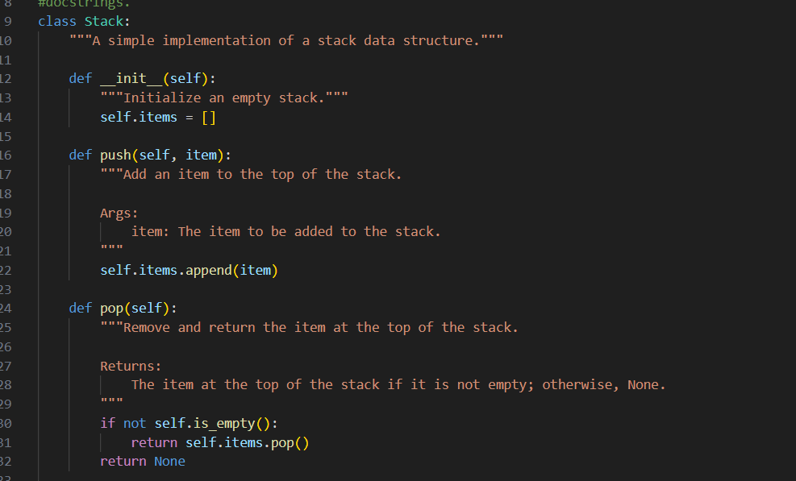
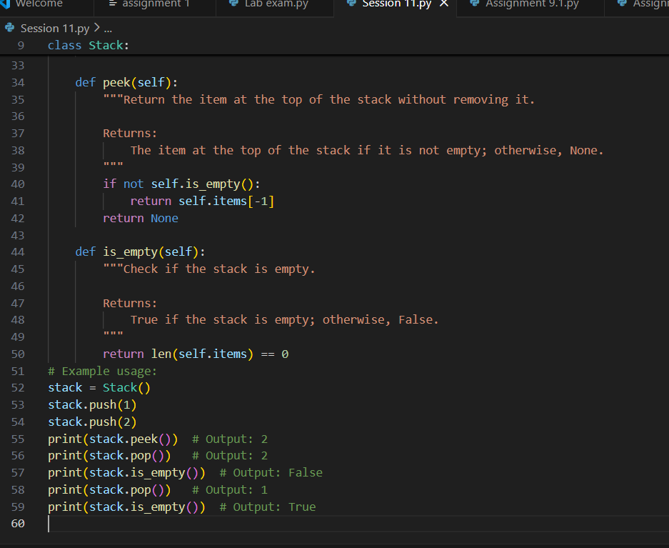
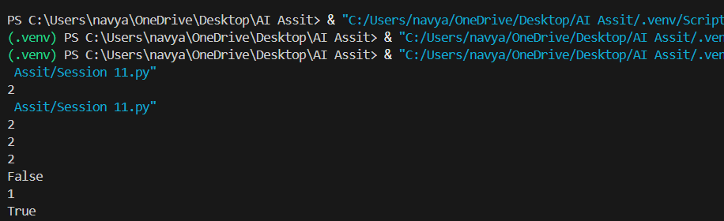
The generated Stack class correctly satisfies the given task requirements.
- All required methods are implemented:
  - Push () adds an element to the top of the stack.
  - Pop () removes and returns the top element.
  - Peek () returns the top element without removing it.
  - is_ empty () checks whether the stack is empty.
- Internal Implementation:
  - The stack uses a Python list (self. items) to store elements, which is appropriate and efficient.
- Docstrings:
  - The class and all methods include clear and meaningful docstrings.
  - Parameters and return values are properly described.
- Edge Case Handling:
  - The pop () and peek () methods safely handle empty stack situations by returning None.
- Example Usage:
  - The example demonstrates correct stack behaviour (LIFO – Last In, First Out)
Task 2:
Prompt:
Generate a complete Python implementation of a Queue class using Python lists. The class should follow the FIFO (First In, First Out) principle and include the methods enqueue(item), dequeue (), peek (), and size (). Include proper Google-style docstrings for the class and each method. Handle edge cases such as dequeue or peeking from an empty queue. Provide a short example usage demonstrating the queue operations.
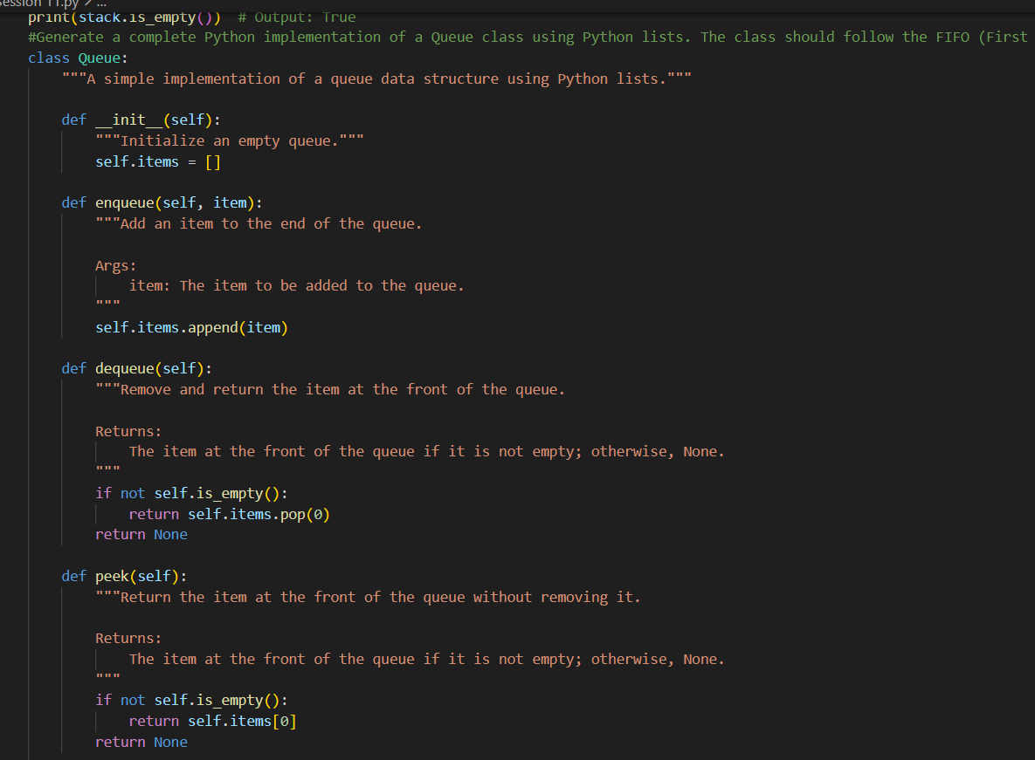
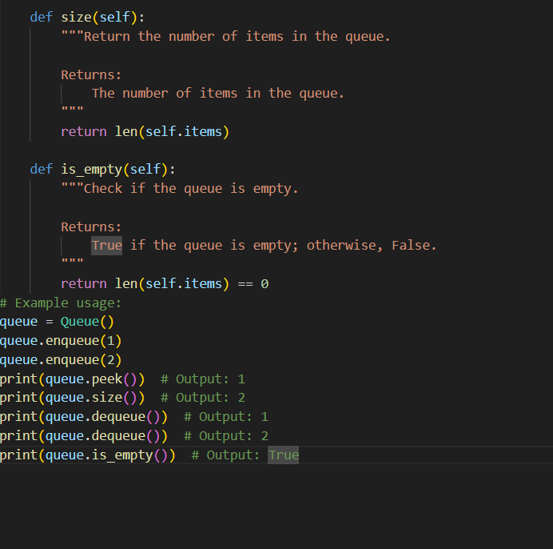
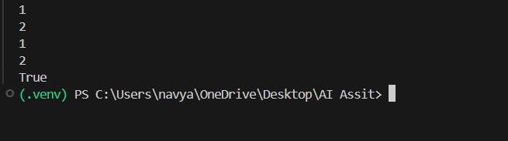
Observation
- All required methods (enqueue, dequeue, peek, size, is_empty) are implemented.
- Follows FIFO (First In First Out) principle correctly.
- Docstrings are properly written.
- Empty queue case is handled safely.
- Example usage demonstrates correct behaviour
Task 3:
Prompt:
Generate a complete Python implementation of a Singly Linked List. Create a Node class and a LinkedList class. The LinkedList class should include insert(data) and display() methods. Add proper Google-style docstrings for all classes and methods. Ensure the implementation is functional and include a short example usage demonstrating insertion and display.
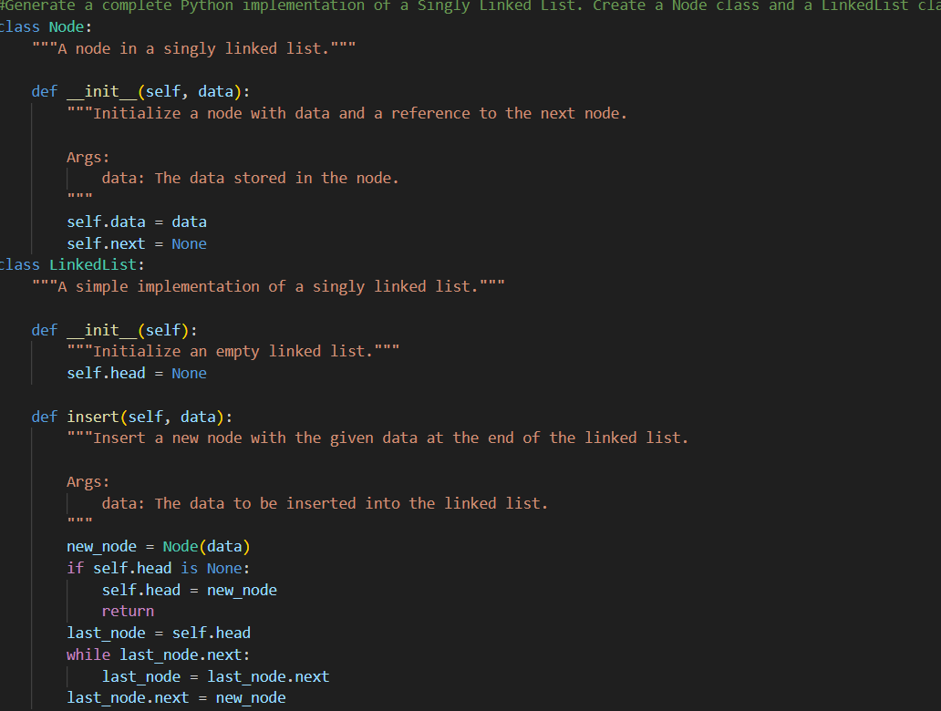
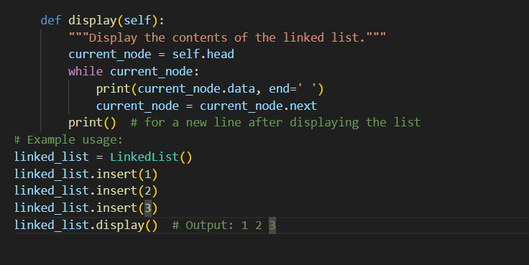
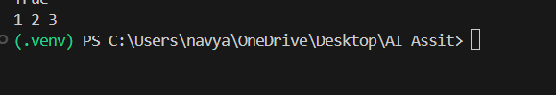
Observation
- Node and LinkedList classes are correctly defined.
- Insert () adds elements at the end properly.
- Display () prints elements correctly.
- Code structure is clean and readable.
- Docstrings are included.

Task 4:
Prompt:
Generate a complete Python implementation of a Binary Search Tree (BST). The class should include recursive insert(value) and in order traversal () methods. Ensure the insert method maintains BST properties. Add clear Google-style docstrings and provide example usage demonstrating insertion and in-order traversal.
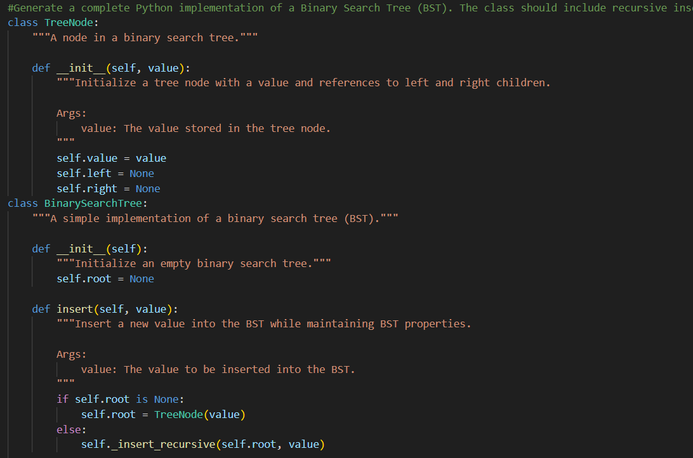
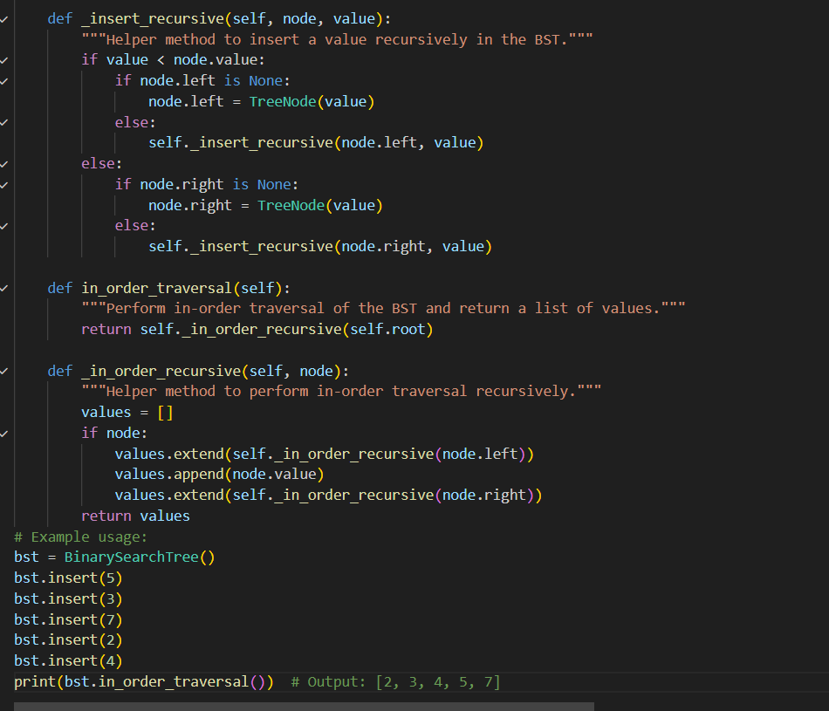
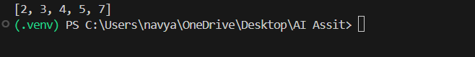
Observation
- Recursive insertion maintains BST properties.
- In-order traversal correctly returns sorted elements.
- Helper recursive methods are properly used.
- Code is structured and documented clearly.
- Example output verifies correctness.

Task 5
Hash Table Prompt
Generate a Python implementation of a Hash Table with collision handling using chaining (linked lists). Include insert (key, value), search(key), and delete(key) methods. Add clear comments and Google-style docstrings explaining each method. Provide example usage to demonstrate insertion, searching, and deletion.
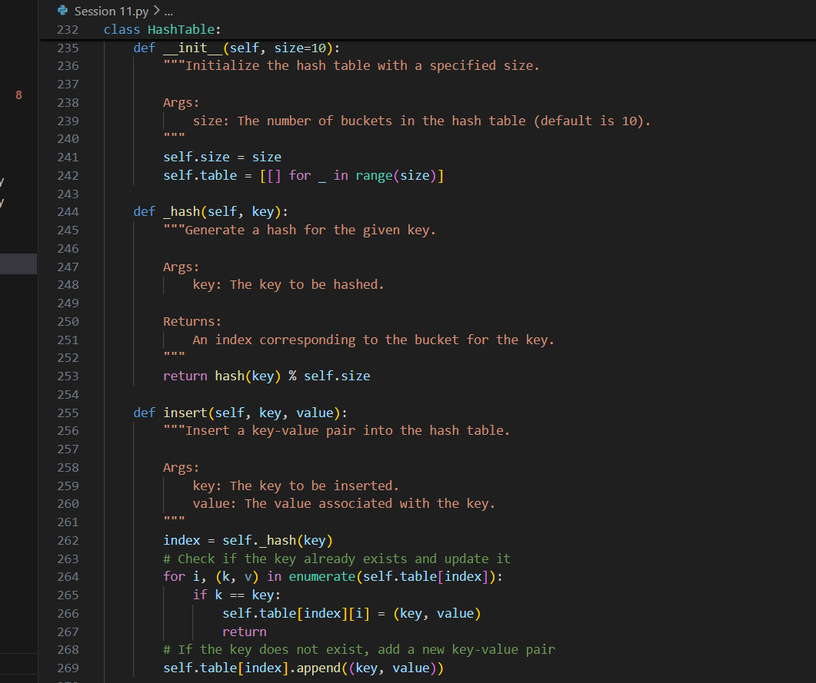
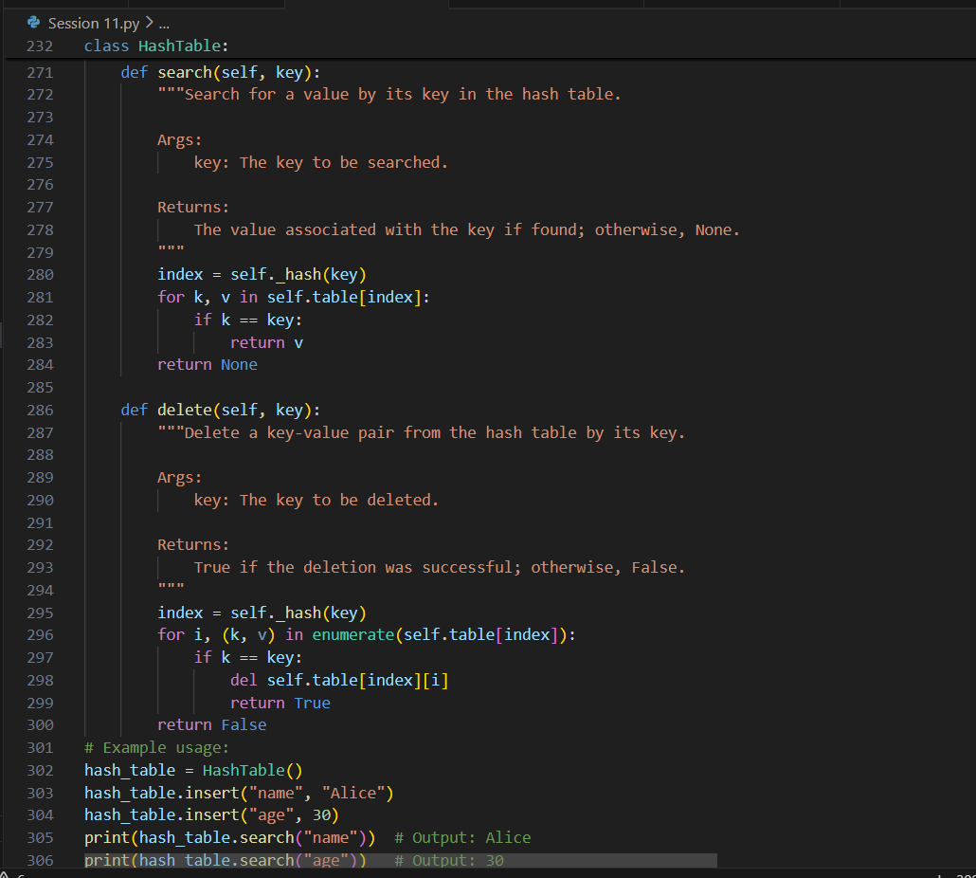
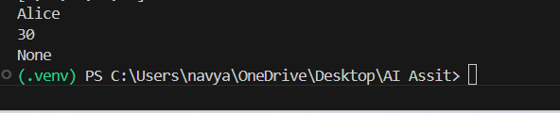
Observation
- Collision handling is correctly implemented using chaining.
- insert, search, and delete methods work properly.
- Existing keys are updated correctly.
- Docstrings and comments explain functionality clearly.
- Example usage demonstrates correct operations.
Task 6
Graph (Adjacency List) Prompt
Generate a Python implementation of a Graph using an adjacency list representation. Include methods add_ vertex(vertex), add_ edge (v1, v2), and display (). Add proper Google-style docstrings and provide example usage showing how vertices and edges are added and displayed.
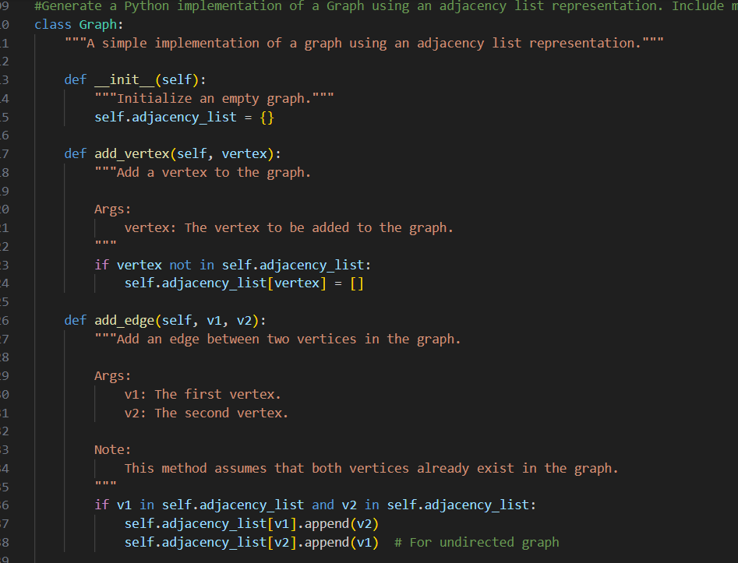

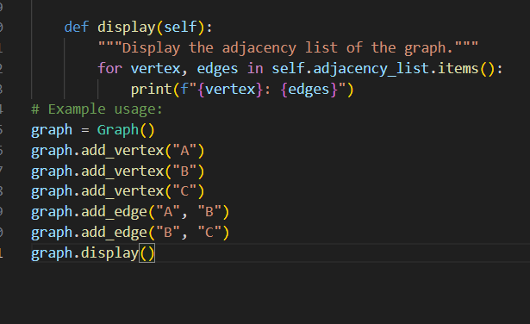
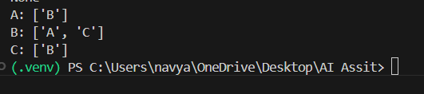
Observation
- Graph is correctly implemented using an adjacency list (dictionary).
- add_ vertex and add_ edge methods function properly.
- Undirected graph behaviour is correctly handled.
- Display () prints adjacency list clearly.
- Code includes proper documentation.

Task 7
Priority Queue Prompt
Generate a Python implementation of a Priority Queue using the built-in q module. Include methods enqueue (item, priority), dequeue (), and display (). Add proper Google-style docstrings and example usage demonstrating priority-based removal (highest priority first).
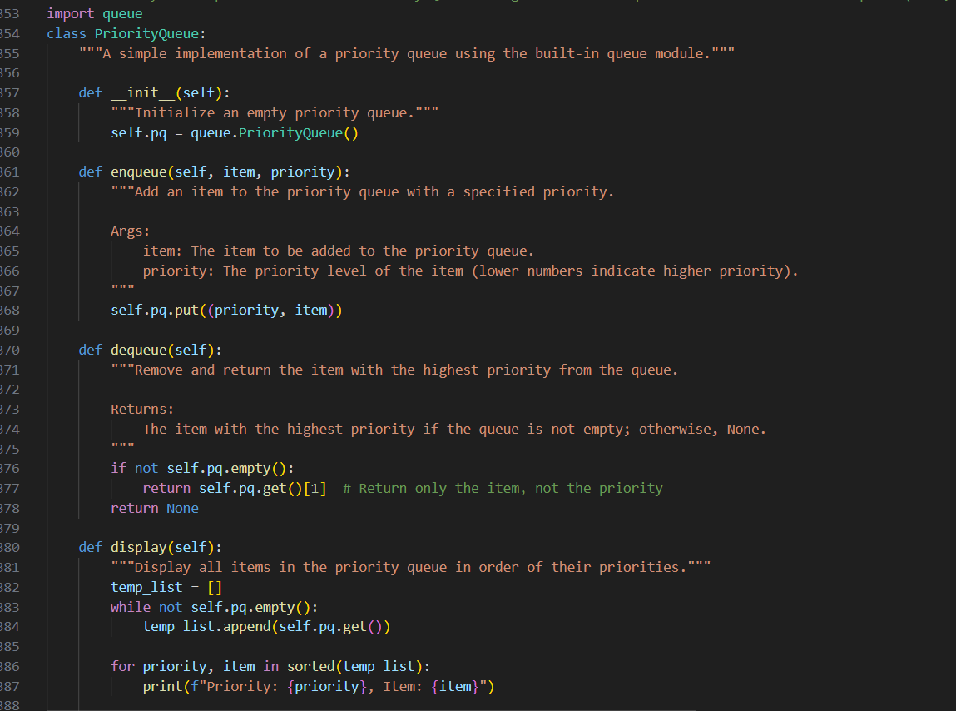
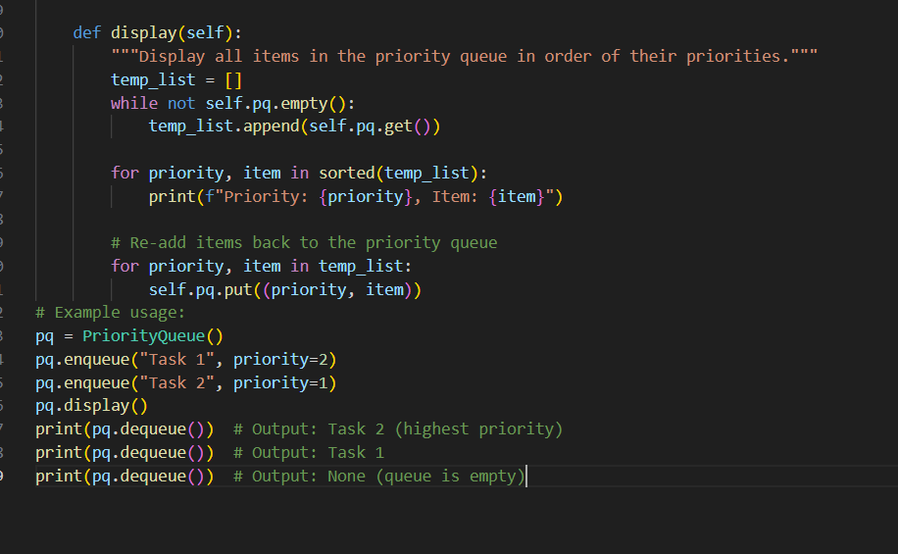
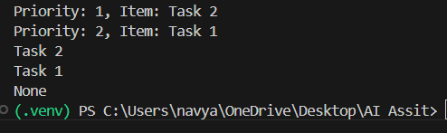
Observation
- Priority queue is implemented using Python’s built-in module.
- enqueue and dequeue correctly manage priority.
- Highest priority (lowest number) is removed first.
- Display method temporarily removes and restores elements properly.
- Edge cases are handled.
Task: 8
Deque Prompt
Generate a Python implementation of a double-ended queue using collections. Deque. Create a class Deque DS with methods to insert and remove elements from both front and rear. Add proper Google-style docstrings and example usage.
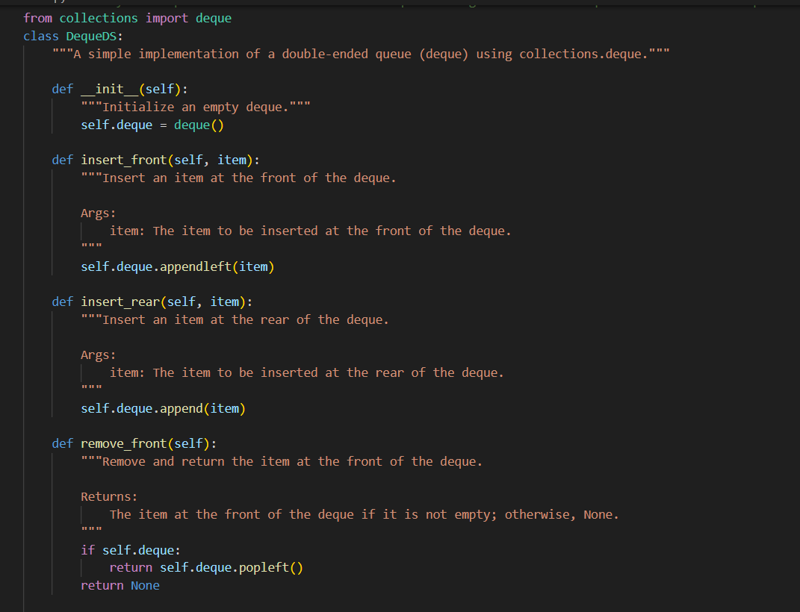
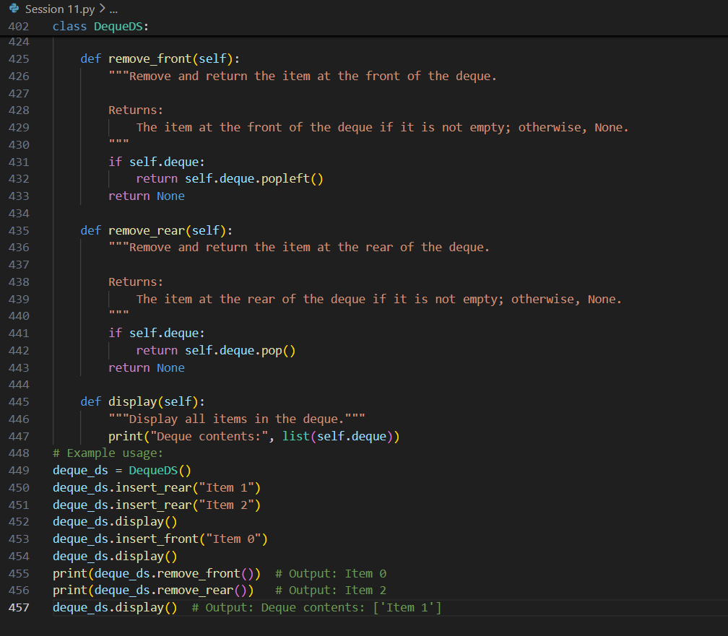
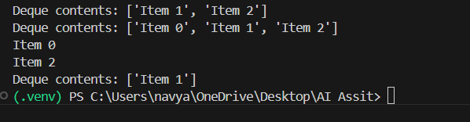
Observation
- Implemented correctly using collections deque.
- Supports insertion and removal from both ends.
- Methods handle empty deque safely.
- Display method shows contents clearly.
- Docstrings are properly written

Task 9
Campus Resource Management System Prompt
Generate a structured response for a Campus Resource Management System.
- Select the most appropriate data structure (Stack, Queue, Priority Queue, Linked List, BST, Graph, Hash Table, Deque) for each feature:
  - Student Attendance Tracking
  - Event Registration System
  - Library Book Borrowing
  - Bus Scheduling System
  - Cafeteria Order Queue
- Present the answer in a table format:
Feature → Chosen Data Structure → Justification (2–3 sentences each)
- Implement one selected feature as a complete working Python program with proper comments and Google-style docstrings.
- | Feature | Chosen Data Structure | Justification |
- |-----------------------------|-----------------------|-------------------------------------------------------------------------------------------------|
- | Student Attendance Tracking | Stack | A stack is ideal for tracking attendance because it follows the Last-In-First-Out (LIFO) principle. New students are added to the top of the stack, and attendance can be recorded by removing students from the top. This ensures that the most recently added student is marked as present first. |
- | Event Registration System | Queue | A queue is suitable for event registration because it follows the First-In-First-Out (FIFO) principle. Registrations are processed in the order they are received, ensuring fairness and consistency in handling registrations. |
- | Library Book Borrowing | Stack | A stack is appropriate for library book borrowing because books are borrowed and returned in a LIFO manner. The most recently returned book is typically the next one to be borrowed, making a stack an intuitive choice for managing book availability. |
- | Bus Scheduling System | Priority Queue | A priority queue is ideal for bus scheduling because different buses may have different priorities based on their routes or schedules. Higher-priority buses are scheduled first, ensuring efficient resource allocation and timely departures. |
- | Cafeteria Order Queue | Queue | A queue is suitable for cafeteria orders because it ensures that orders are processed in the order they are received, maintaining fairness and preventing any order from being skipped or delayed unnecessarily. |

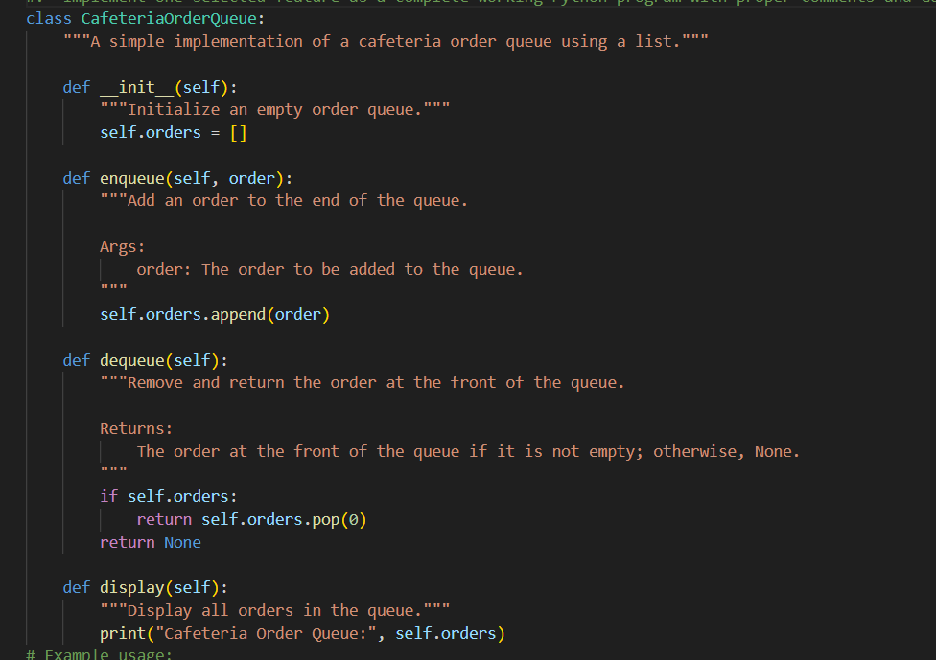
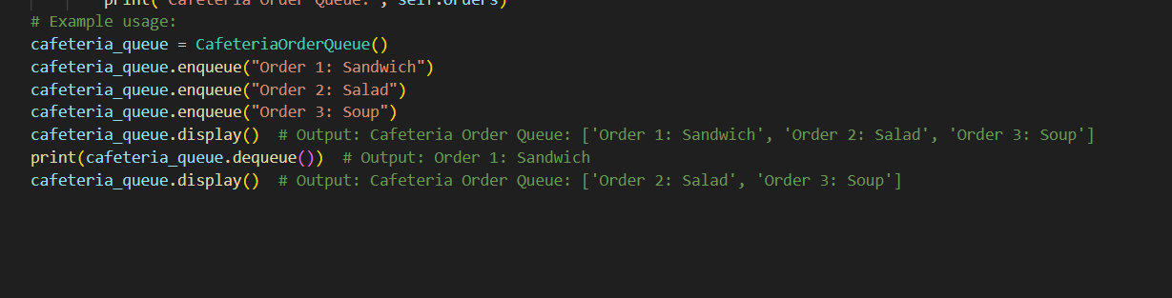
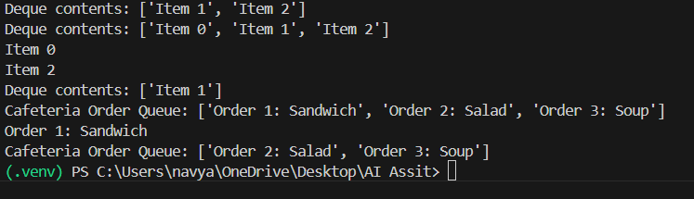
Observation
- Appropriate data structure (Queue) was selected for Cafeteria Order feature.
- FIFO behaviour correctly models real-world serving order.
- Implementation is simple and functional.
- Code is properly documented.
- Example usage demonstrates correct behaviour

Task 10
Smart E-Commerce Platform Prompt
Generate a structured response for a Smart E-Commerce System.
- Select the most appropriate data structure (Stack, Queue, Priority Queue, Linked List, BST, Graph, Hash Table, Deque) for each feature:
  - Shopping Cart Management
  - Order Processing System
  - Top-Selling Products Tracker
  - Product Search Engine
  - Delivery Route Planning
- Present the answer in a table format:
Feature → Chosen Data Structure → Justification (2–3 sentences each)
- Implement one selected feature as a complete working Python program with proper comments and Google-style docstrings.
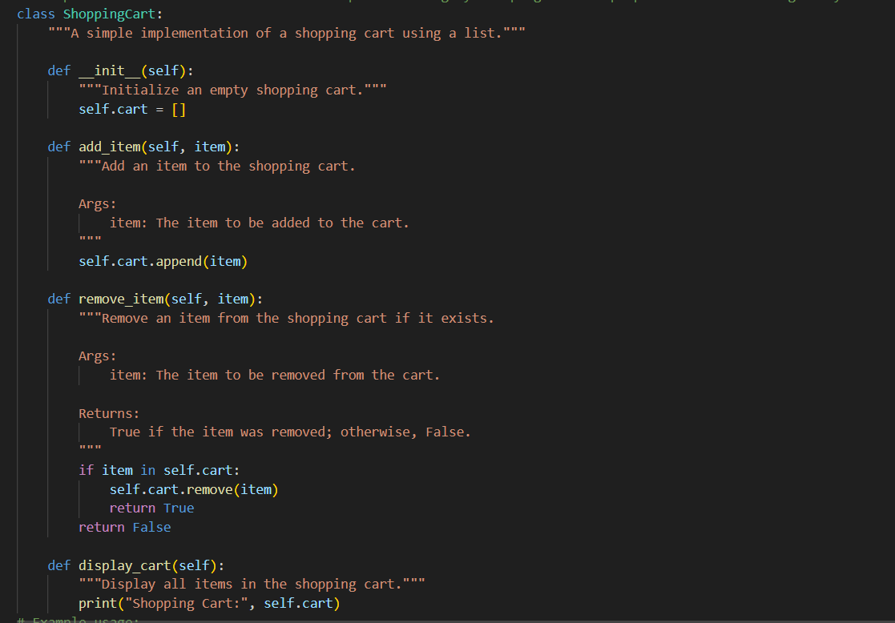
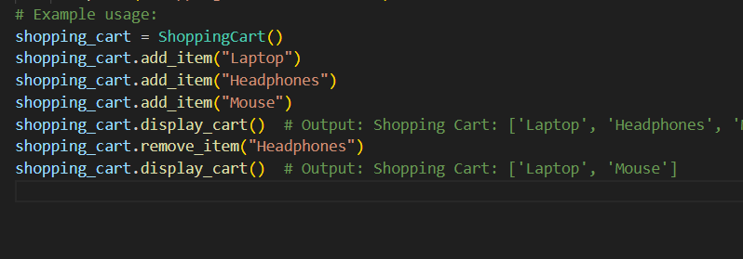
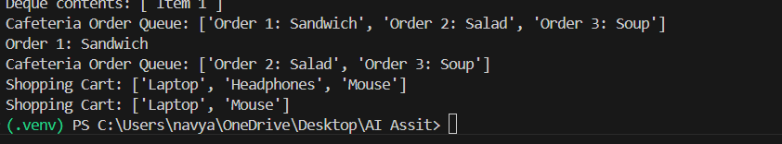

Observation
- Shopping cart implemented using list (dynamic and simple).
- Add and remove operations work correctly.
- Code includes proper documentation.
- Example usage verifies functionality.
- Suitable data structure chosen for the feature.

